**LEX**

It is a tool or software which automatically generates a lexical analyzer (finite Automata). It takes as its input a LEX source program and produces lexical Analyzer as its output. Lexical Analyzer will convert the input string entered by the user into tokens as its output.

LEX is a program generator designed for lexical processing of character input/output stream. Anything from simple text search program that looks for pattern in its input-output file to a C compiler that transforms a program into optimized code.

In program with structure input-output two tasks occurs over and over. It can divide the input-output into meaningful units and then discovering the relationships among the units for C program (the units are variable names, constants, and strings). This division into units (called tokens) is known as lexical analyzer or LEXING. LEX helps by taking a set of descriptions of possible tokens n producing a routine called a lexical analyzer or LEXER or Scanner.

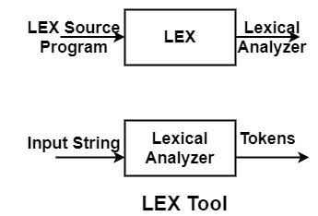

LEX Source Program

It is a language used for specifying or representing Lexical Analyzer.

There are two parts of the LEX source program −

* Auxiliary Definitions
* Translation Rules

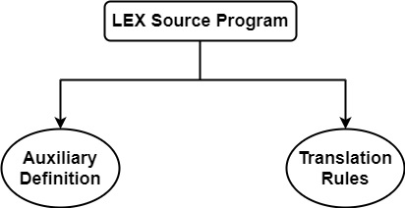

* **Auxiliary Definition**

It denotes the regular expression of the form.

Distinct Names [D1=R1\D2=R2\Dn=Rn][D1=R1\D2=R2\Dn=Rn] Regular Expressions

Where

* Distinct Names (Di)→ Shortcut name of Regular Expression
* Regular Expression (Ri)→ Notation to represent a collection of input symbols.

**Example**

Auxiliary Definition for Identifiers −

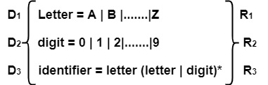

**Auxiliary Definition for Signed Numbers**

integer=digit digit*

sign = + | -

signedinteger = sign integer

**Auxiliary Definition for Decimal Numbers**

decimal = signedinteger . integer | sign.integer

**Auxiliary Definition for Exponential Numbers**

Exponential – No = (decimal | signedinteger) E signedinteger

**Auxiliary Definition for Real Numbers**

Real-No. = decimal | Exponential – No

* **Translation Rules**

It is a set of rules or actions which tells Lexical Analyzer what it has to do or what it has to return to parser on encountering the token.

It consists of statements of the form −

P1 {Action1}

P2 {Action2}

.

.

.

Pn {Actionn}

Where

**Pi** → Pattern or Regular Expression consisting of input alphabets and Auxiliary definition names.

**Actioni** → It is a piece of code that gets executed whenever a token is Recognized. Each Actioni specifies a set of statements to be executed whenever each regular expression or pattern **Pi** matches with the input string.

**Example**

Translation Rules for "Keywords"

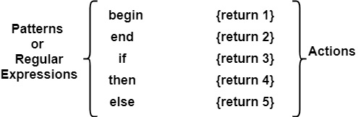

We can see that if Lexical Analyzer is given the input "begin", it will recognize the token "begin" and Lexical Analyzer will return 1 as integer code to the parser.

**Translation Rules for "Identifiers"**

letter (letter + digit)* {Install ( );return 6}

If Lexical Analyzer is given the token which is an "identifier", then the Action taken by the Lexical Analyzer is to install or store the name in the symbol table & return value 6 as integer code to the parser.

# [YACC in Compiler Design](https://www.tutorialandexample.com/yacc)

**YACC**

YACC is known as **Yet Another Compiler Compiler**. It is used to produce the source code of the syntactic analyzer of the language produced by LALR (1) grammar. The input of YACC is the rule or grammar, and the output is a C program. Stephen C. Johnson creates the first kind of YACC. If we have a file **translate.y** that consists of YACC specification, then the UNIX system command is:

YACC translate.y

**This command converts the file translate.y into a C file y.tab.c**. It represents an LALR parser prepared in C with some other user’s prepared C routines. By compiling y.tab.c along with the ly library, we will get the desired object program a.out that performs the operation defined by the original YACC program.

The construction of translation using YACC is illustrated in the figure below:

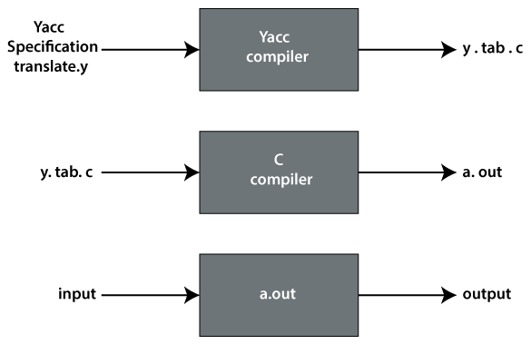

A YACC source program contains three parts:

* **Declarations**

%%

* **Translation rules**

%%

* **Supporting C rules**

**Declarations Part**

This part of YACC has two sections; both are optional. The first section has ordinary C declarations, which is delimited by %{ and %}. Any temporary variable used by the second and third sections will be kept in this part. See the below code:

%{

#include <ctype.h>

%}

%token DIGIT

%%

line               :  expr  ‘\n’                { printf("%d\n", $1); }

                     ;

expr              :  expr   '+' term          { $$ = $1 + $3; }

                     |   term

                     ;

term              :  term '*' factor           { $$ = $1 * $3; }

                     |  factor

                     ;

factor            :  ‘(‘ expr ’)’                  { $$ = $2; }

                     |    DIGIT

                     ;

%%

yylex() {

int c;

c = getchar();

if (isdigit(c)) {

yylval = c-'0';

return DIGIT;

}

return c;

}

In the above code, the declaration part only contains the include statement.

#include <ctype.h>

Declaration of grammar tokens also comes in the declaration part.

%token DIGIT

This part defined the tokens that can be used in the later parts of a YACC specification.

**Translation Rule Part**

After the first %% pair in the YACC specification part, we place the translation rules. Every rule has a grammar production and the associated semantic action.

A set of productions:

                         <head> => <body>1 | <body>2 | ..... | <body>n

would be written in YACC as

                            <head>    :      <body>1          {<semantic action>1}

                                            |      <body>2          {<semantic action>2}

                                                     .....

                                             |       <body>n         {<semantic action>n}

                                             ;

In a YACC production, an unquoted string of letters and digits that are not considered tokens is treated as non-terminals.

The semantic action of YACC is a set of C statements. In a semantic action, the symbol $$ considered to be an attribute value associated with the head's non-terminal. While $i considered as the value associated with the ith grammar production of the body.

If we have left only with associated production, the semantic action will be performed. The value of $$ is computed in terms of $i's by semantic action.

**Supporting C–Rules**

It is the last part of the YACC specification and should provide a lexical analyzer named **yylex**(). These produced tokens have the token's name and are associated with its attribute value. Whenever any token like DIGIT is returned, the returned token name should have been declared in the first part of the YACC specification.

The attribute value which is associated with a token will communicate to the parser through a variable called **yylval**. This variable is defined by a YACC.

Whenever YACC reports that there is a conflict in parsing-action, we should have to create and consult the file **y.output** to see why this conflict in the parsing-action has arisen and to see whether the conflict has been resolved smoothly or not.

Instructed YACC can reduce all parsing action conflict with the help of two rules that are mentioned below:

* A reduce/reduce conflict can be removed by choosing the production which has conflict mentioned earlier in the YACC specification.
* A shift/reduce conflict is reduced in favor of shift. A shift/reduce conflict that arises from the dangling-else ambiguity can be solved correctly using this rule.
* Prototype Design Pattern is a Creational Design Pattern that ***helps in the prototyping(creating/copying cheaply) of an object using separate methods or polymorphic classes***. You can consider the prototype as a template of an object before the actual object is constructed.
* why we need a Prototype Design Pattern in C++ i.e. motivation, prototype factory & leveraging prototype design pattern to implement virtual copy constructor.
* Some Creational Design Patterns are:
* **Factory**
* **Builder**
* **Prototype**
* **Singleton**